1. **git常用命令结合若干个使用场景**

[**https://blog.csdn.net/changyixue/article/details/112183335**](https://blog.csdn.net/changyixue/article/details/112183335)

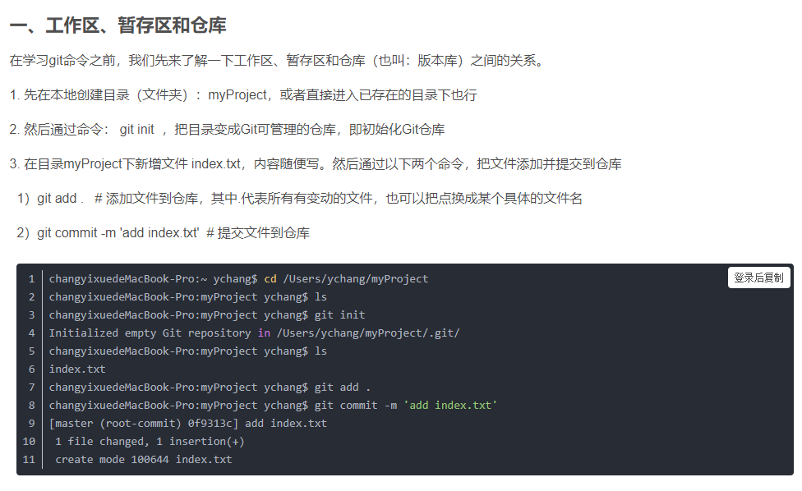

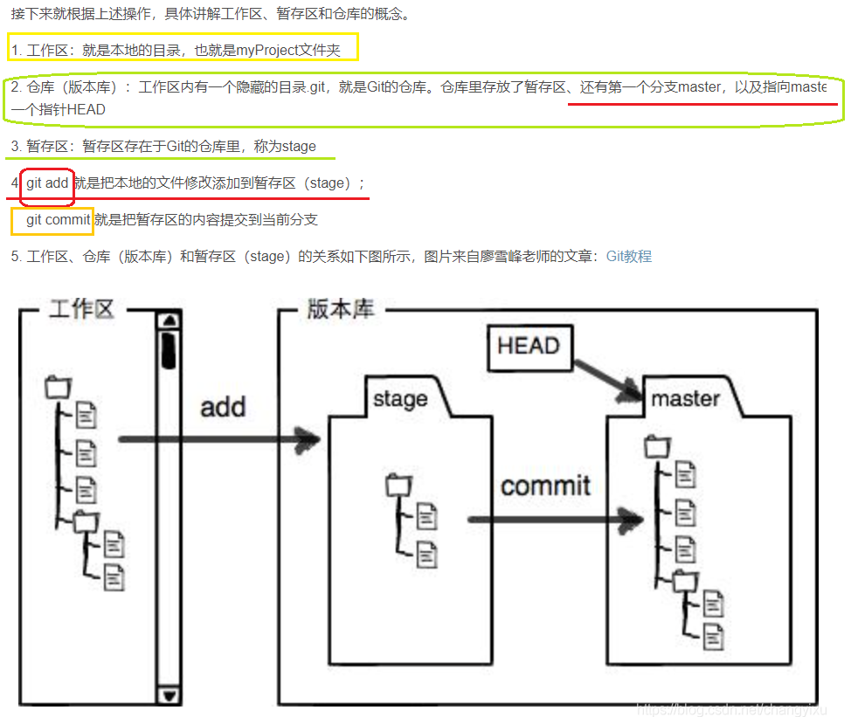

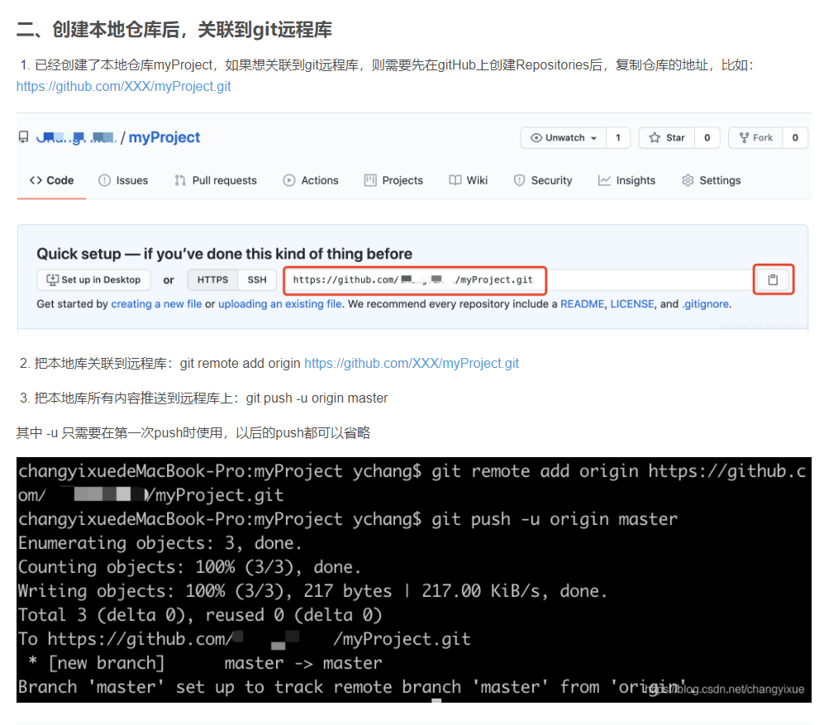

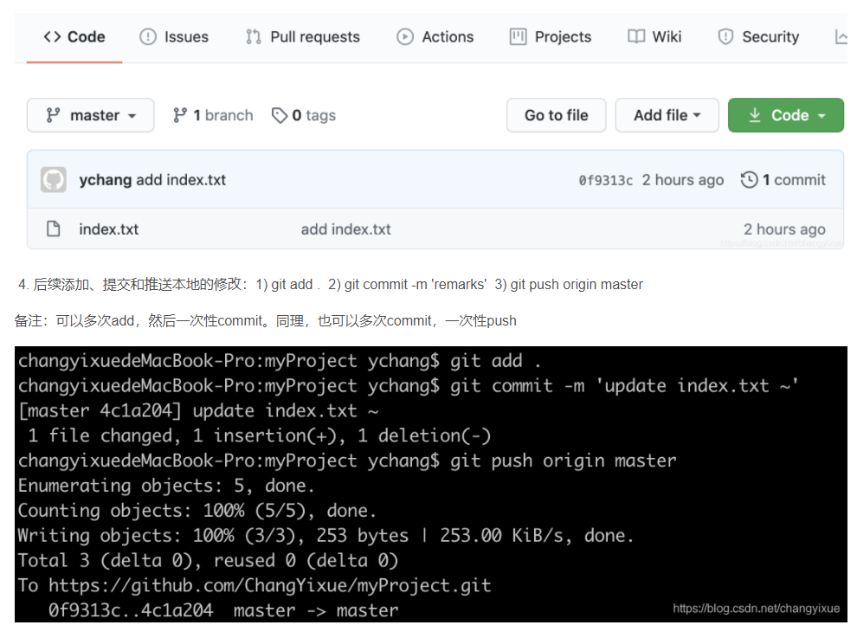

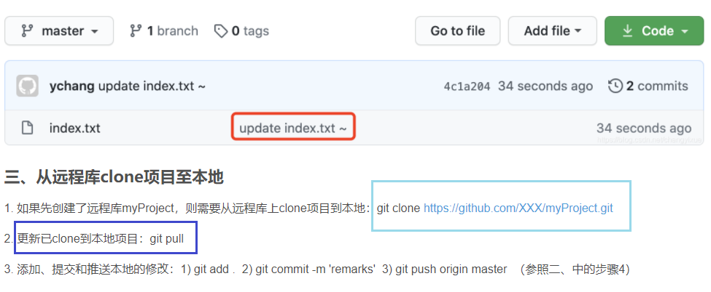

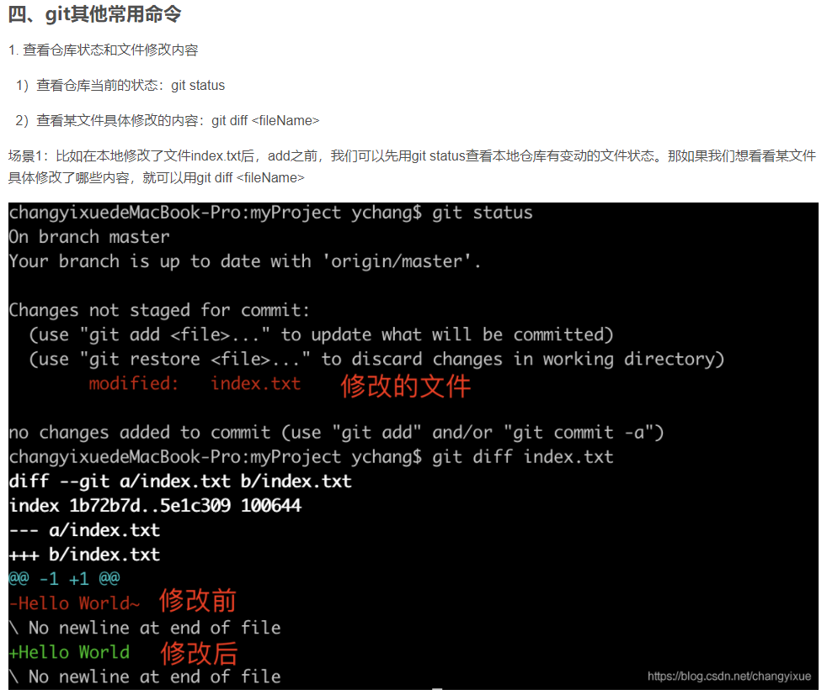

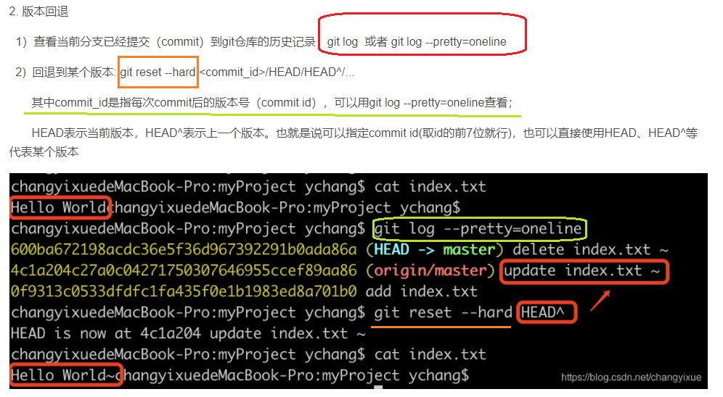

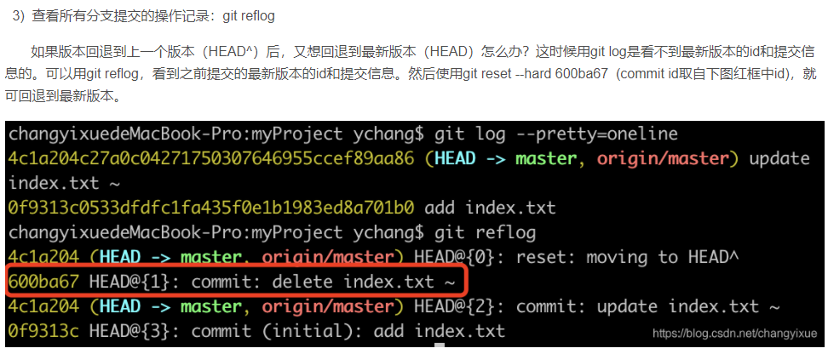

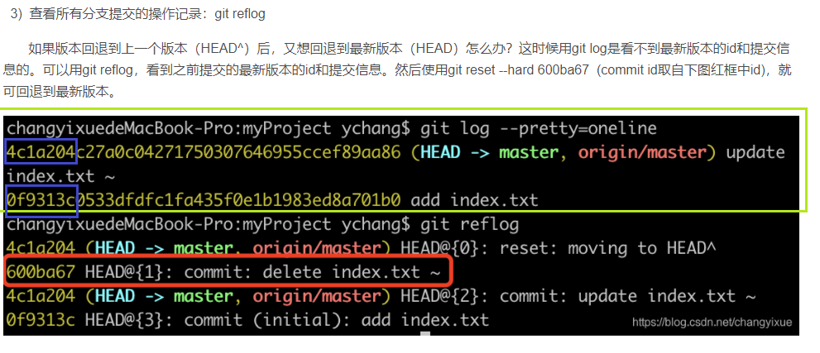

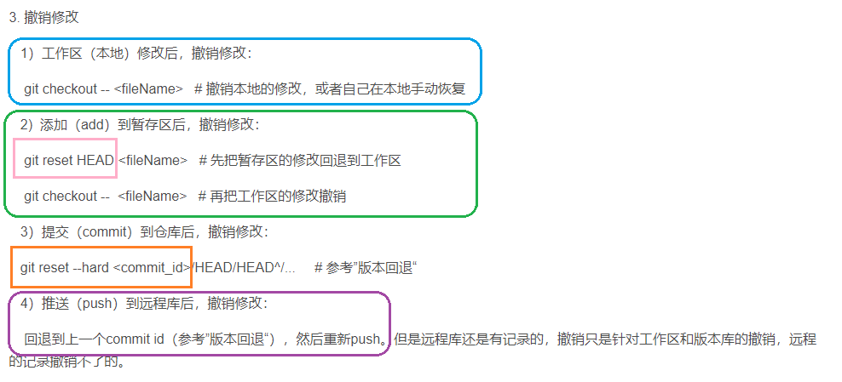

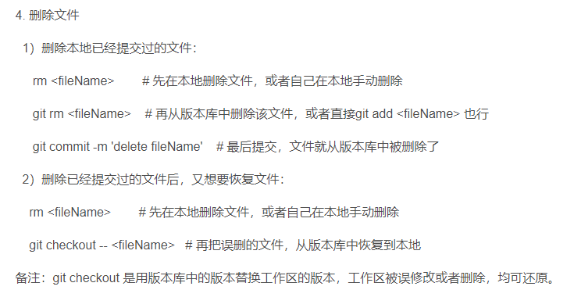

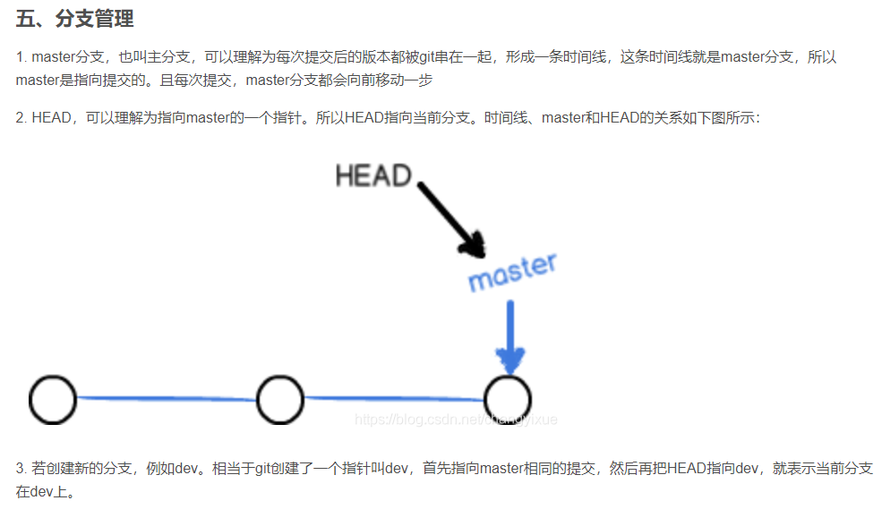

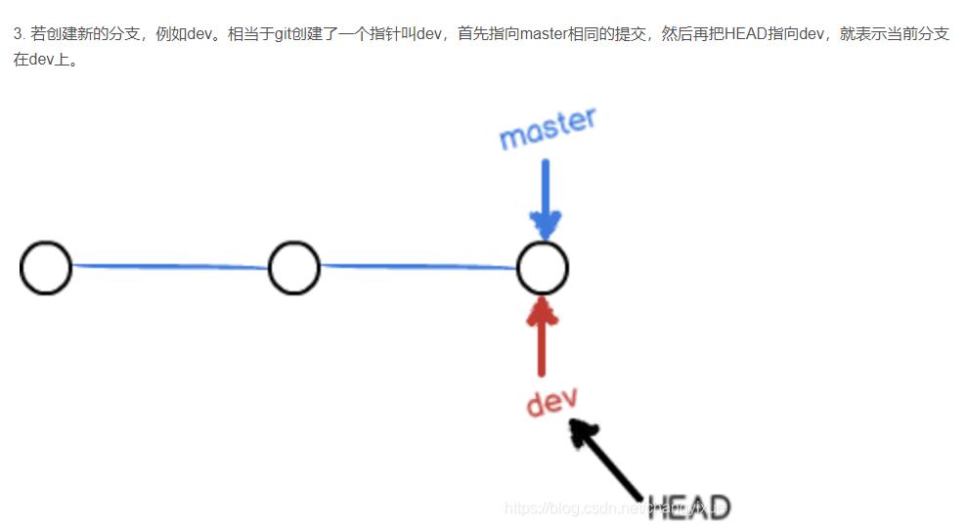

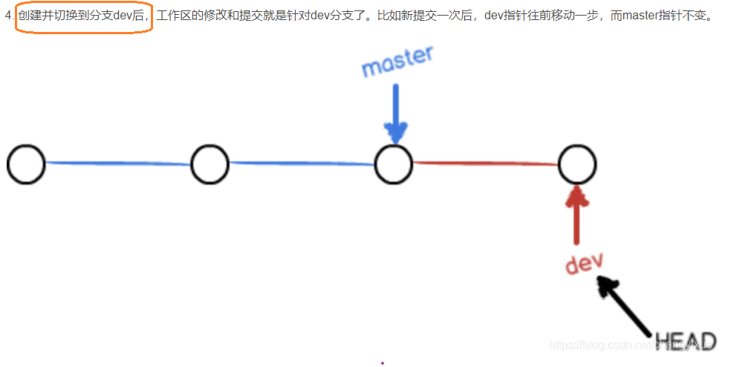

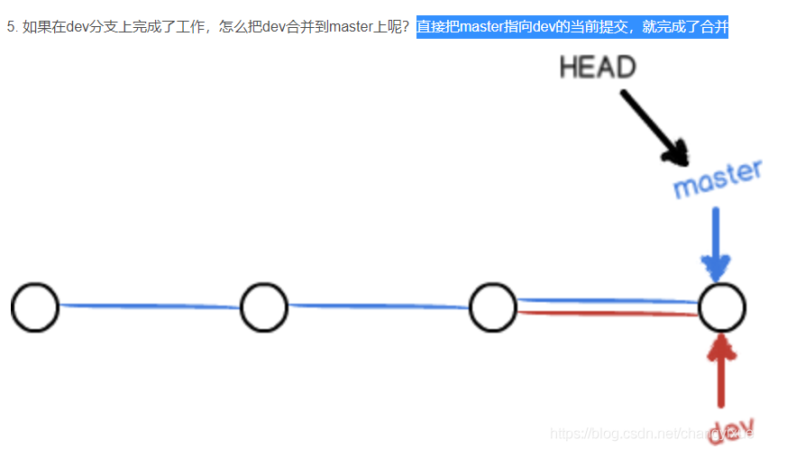

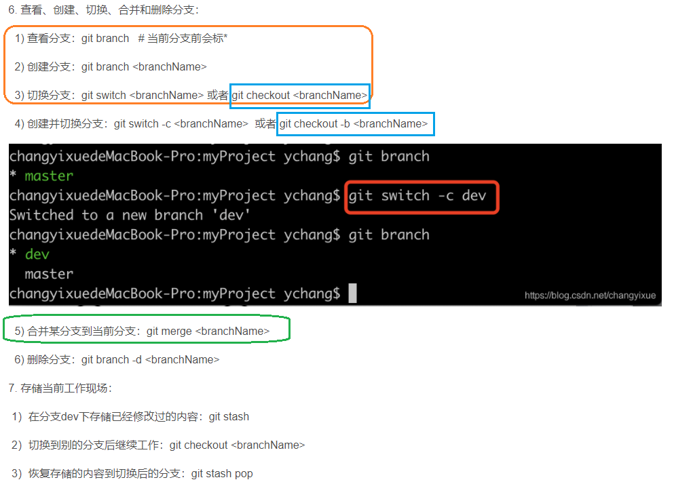

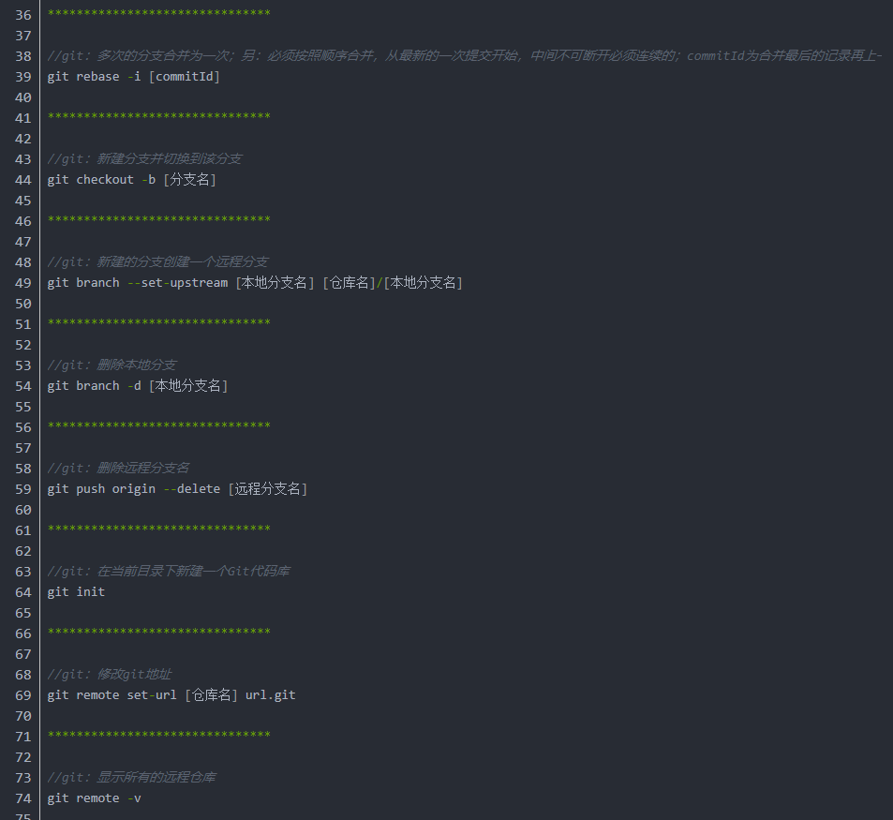

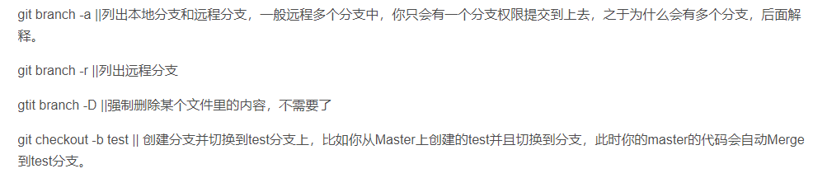

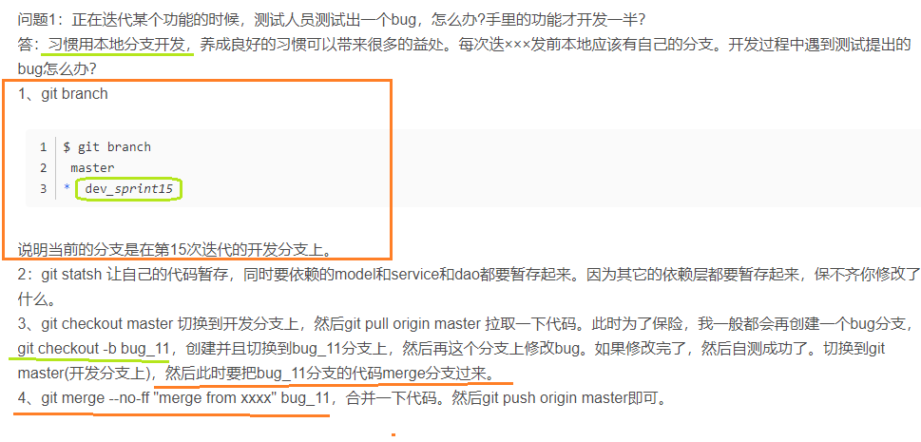

* 浅谈git命令及其使用场景

<https://blog.csdn.net/h2453532874/article/details/97908268?utm_medium=distribute.pc_relevant.none-task-blog-2%7Edefault%7EBlogCommendFromBaidu%7Edefault-5.control&depth_1-utm_source=distribute.pc_relevant.none-task-blog-2%7Edefault%7EBlogCommendFromBaidu%7Edefault-5.control>

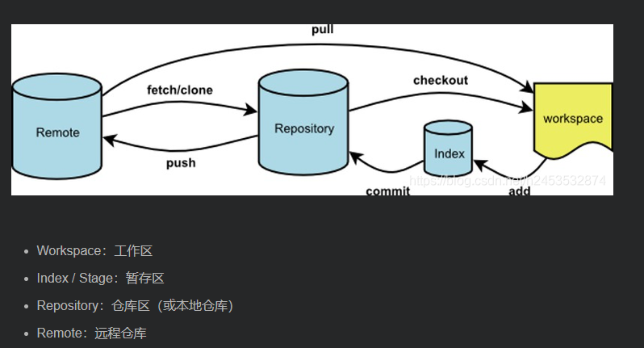

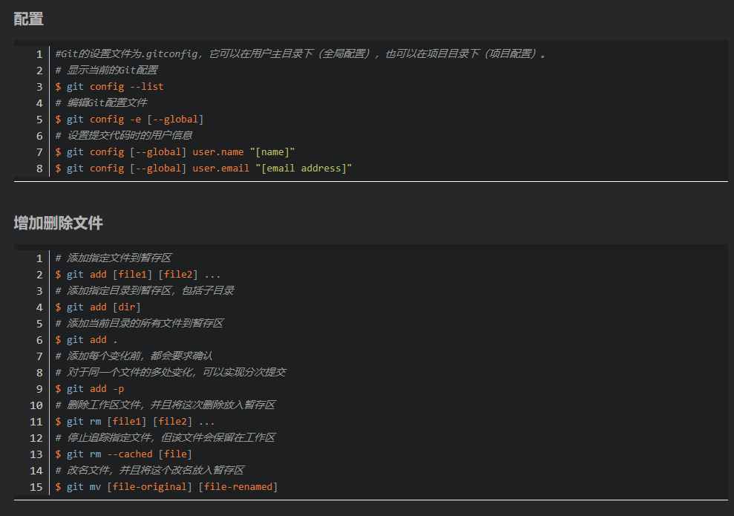

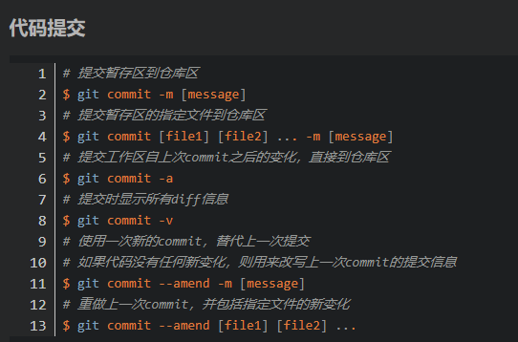

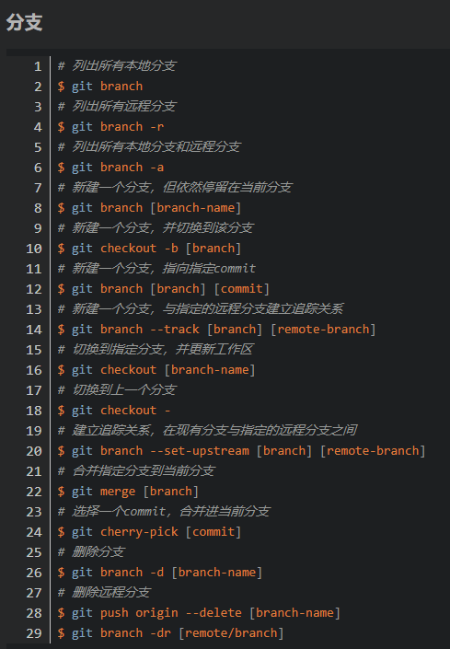

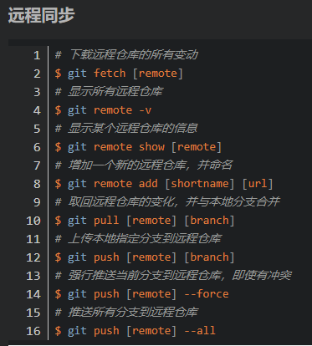

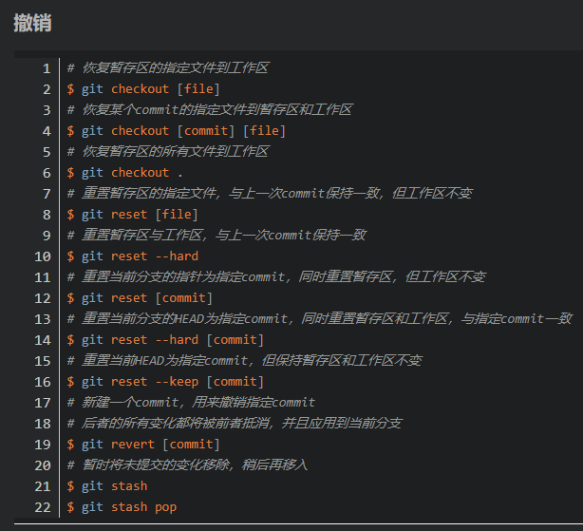

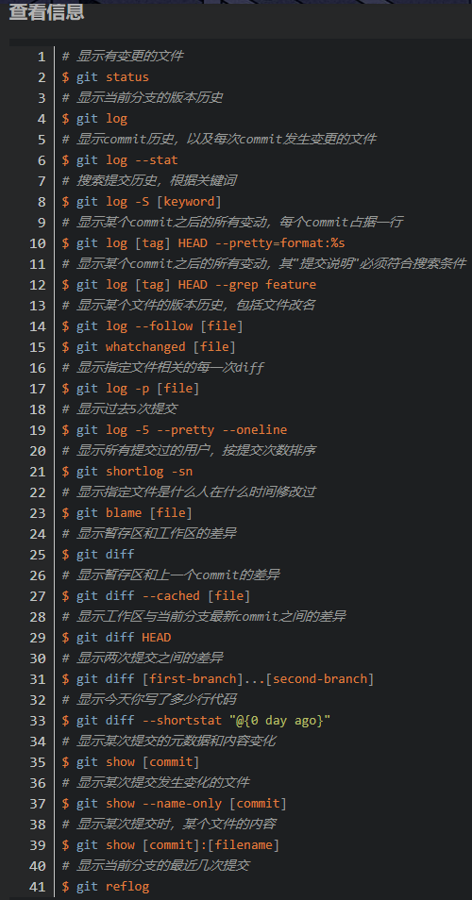

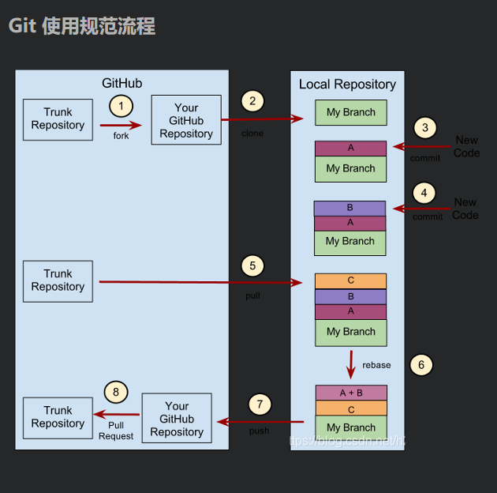

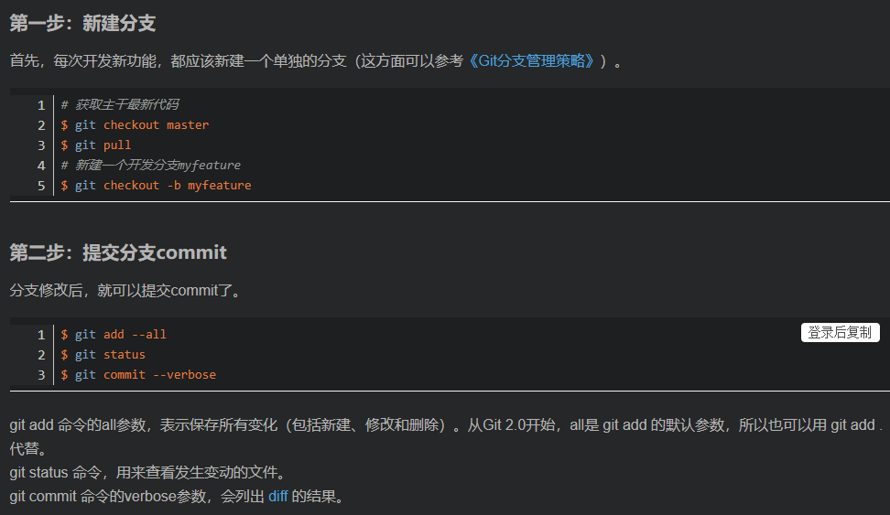

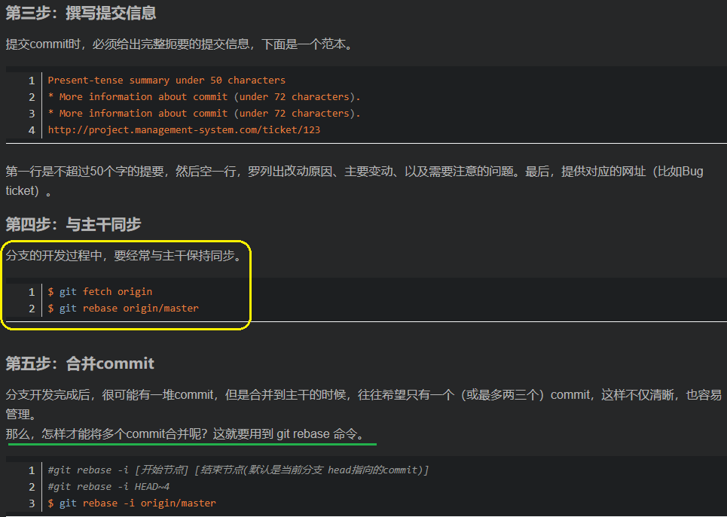

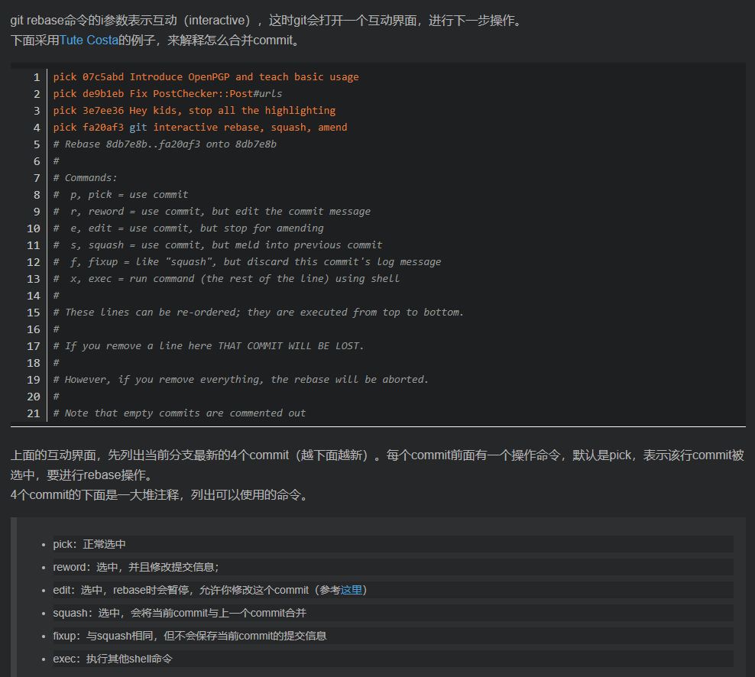

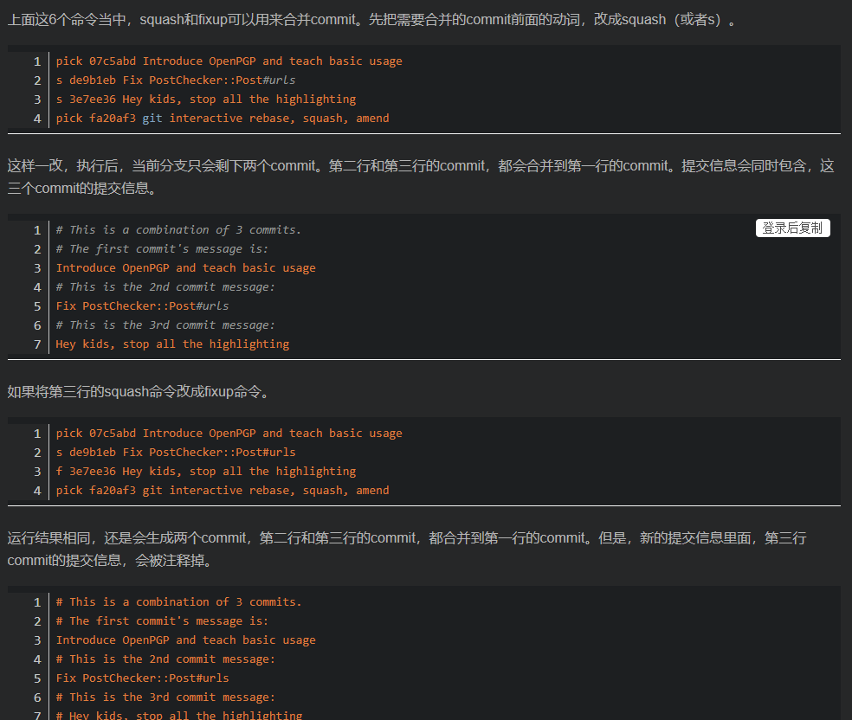

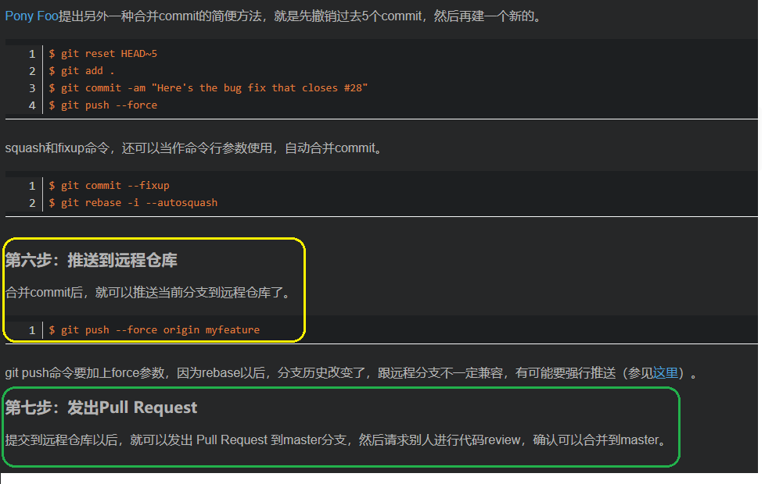

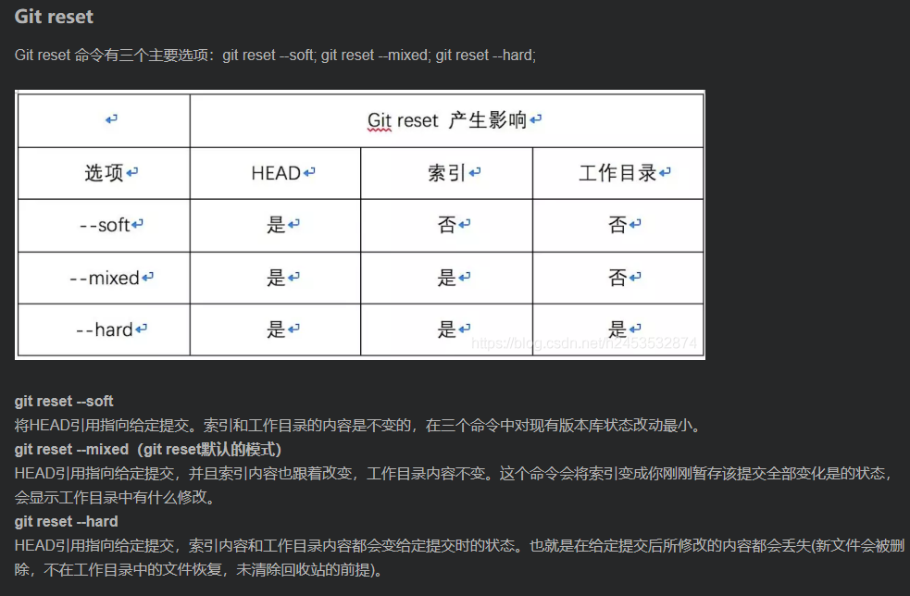

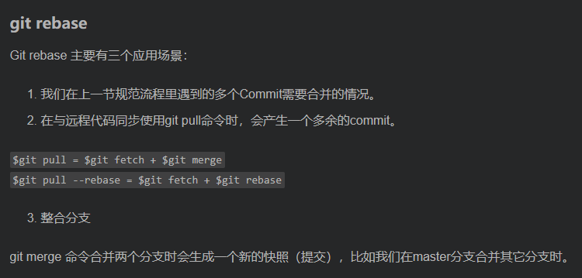

* 11

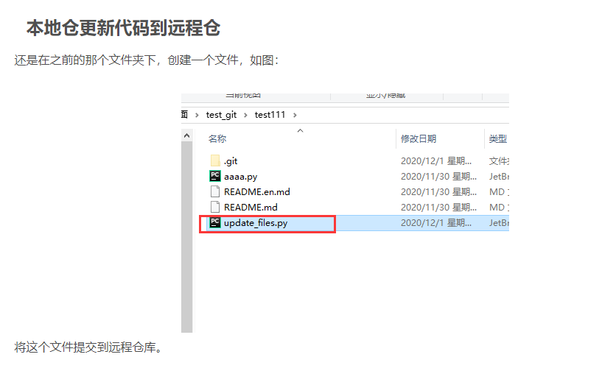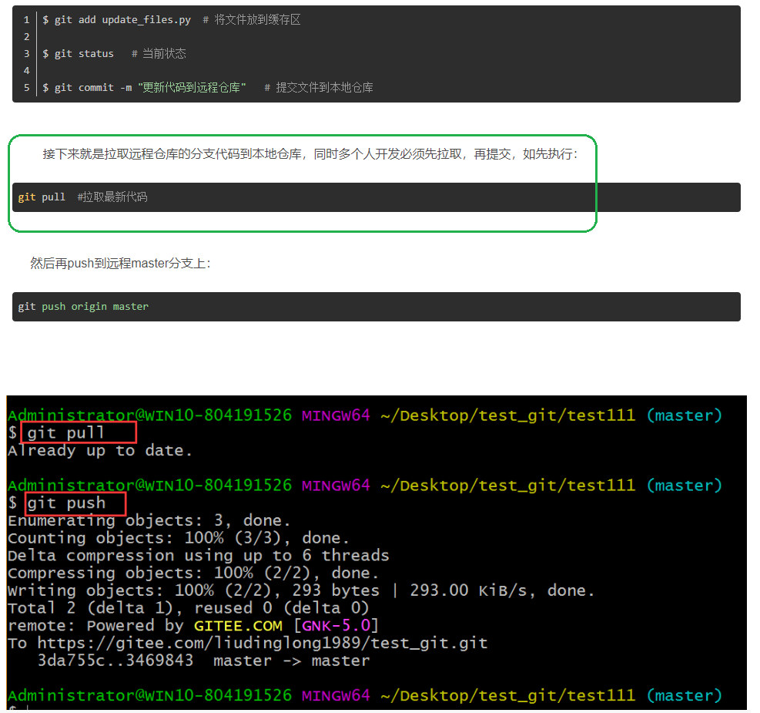

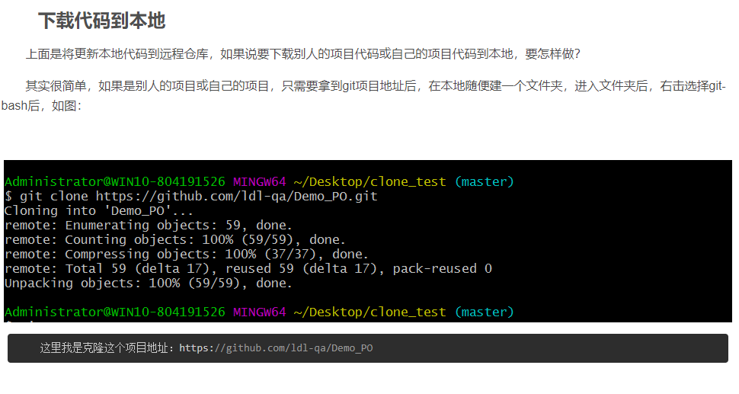

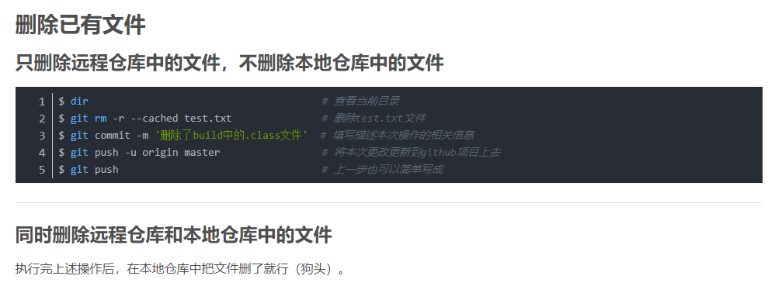

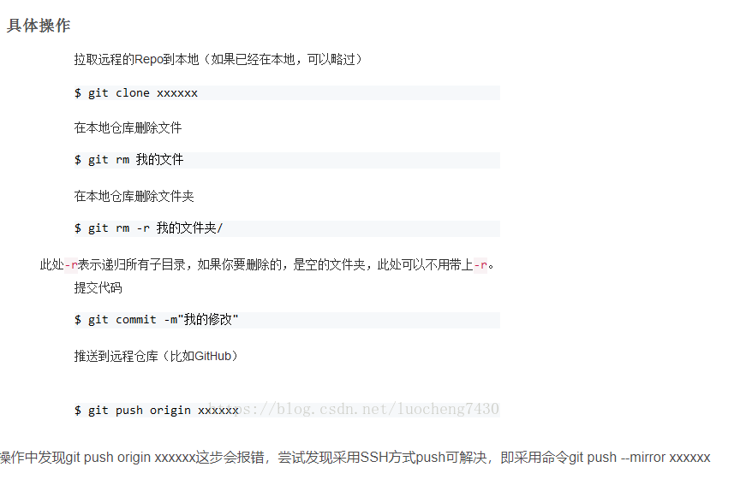

# Git 提交代码步骤

# 

# 

# git提交代码流程

# 

# 

# 

# Git 提交代码

# 

# Git 合并多个提交的正确方式

# 

# 

# 

# 

# 

# git merge 与 git rebase的区别

# 

# 

# 

# 

# git merge 和 git rebase 小结

# 

# 

# 

# 

# git在工作中正确的使用方式----git rebase篇

# 

# 

# 

# 

# 

# 

# 

# 

# 

# 

# 

# 

# 

# 

# 

# 

# 

# 

# 

# 

# 

# 6/17/21

# <https://blog.csdn.net/u012150179/article/details/14047183?utm_medium=distribute.pc_relevant.none-task-blog-2%7Edefault%7EBlogCommendFromMachineLearnPai2%7Edefault-1.control&depth_1-utm_source=distribute.pc_relevant.none-task-blog-2%7Edefault%7EBlogCommendFromMachineLearnPai2%7Edefault-1.control>

# <https://blog.csdn.net/kuangdacaikuang/article/details/79619828?utm_medium=distribute.pc_relevant.none-task-blog-2%7Edefault%7EBlogCommendFromMachineLearnPai2%7Edefault-3.control&depth_1-utm_source=distribute.pc_relevant.none-task-blog-2%7Edefault%7EBlogCommendFromMachineLearnPai2%7Edefault-3.control>

# <https://blog.csdn.net/weixin_44847077/article/details/112408547?utm_medium=distribute.pc_relevant.none-task-blog-baidujs_baidulandingword-0&spm=1001.2101.3001.4242>

# <https://blog.csdn.net/ccblogger/article/details/107002786?utm_medium=distribute.pc_relevant.none-task-blog-baidujs_baidulandingword-4&spm=1001.2101.3001.4242>

# <https://blog.csdn.net/FightFightFight/article/details/80850328?utm_medium=distribute.pc_relevant.none-task-blog-2%7Edefault%7EBlogCommendFromMachineLearnPai2%7Edefault-1.control&depth_1-utm_source=distribute.pc_relevant.none-task-blog-2%7Edefault%7EBlogCommendFromMachineLearnPai2%7Edefault-1.control>

# <https://blog.csdn.net/wangnan9279/article/details/79287631?utm_medium=distribute.pc_relevant.none-task-blog-2%7Edefault%7EBlogCommendFromMachineLearnPai2%7Edefault-2.control&depth_1-utm_source=distribute.pc_relevant.none-task-blog-2%7Edefault%7EBlogCommendFromMachineLearnPai2%7Edefault-2.control>

# <https://blog.csdn.net/Snow_loveLife/article/details/80519998?utm_medium=distribute.pc_relevant.none-task-blog-2%7Edefault%7EBlogCommendFromMachineLearnPai2%7Edefault-2.control&depth_1-utm_source=distribute.pc_relevant.none-task-blog-2%7Edefault%7EBlogCommendFromMachineLearnPai2%7Edefault-2.control>

# <https://blog.csdn.net/qq_41063141/article/details/82623541?utm_medium=distribute.pc_relevant.none-task-blog-baidujs_baidulandingword-1&spm=1001.2101.3001.4242>

# <https://blog.csdn.net/qq_35246620/article/details/69668846?utm_medium=distribute.pc_relevant.none-task-blog-baidujs_baidulandingword-0&spm=1001.2101.3001.4242>

# <https://blog.csdn.net/dc282614966/article/details/89311683?utm_medium=distribute.pc_relevant.none-task-blog-2%7Edefault%7EBlogCommendFromMachineLearnPai2%7Edefault-10.control&depth_1-utm_source=distribute.pc_relevant.none-task-blog-2%7Edefault%7EBlogCommendFromMachineLearnPai2%7Edefault-10.control>

# <https://blog.csdn.net/liudinglong1989/article/details/110420412>

# <https://blog.csdn.net/liudinglong1989/category_10159206.html?utm_medium=distribute.pc_relevant_download.none-task-other-baidujs-2.nonecase&depth_1-utm_source=distribute.pc_relevant_download.none-task-other-baidujs-2.nonecase>